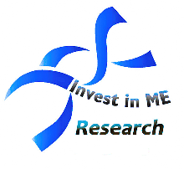

An Invest in ME Research initiative - [www.investinme.org](http://www.investinme.org)

For more details see [www.haveacuppaforme.org](http://www.haveacuppaforme.org)

# Tea & Coffee morning – All welcome!

## There is a text box here for you to fill in your local ME group details

Place the date of HACFME meeting here

All money raised will go towards vital biological research into Myalgic Encephalomyelitis (M.E.)

M.E. is a serious neurological illness that can leave people of all ages and from all walks of life bedbound and housebound for years at a time.

Come along to:

<place the venue address here>

From: <place the time here>